|  |
| --- |
| rest webserver for mongodb |
| with user authentication  winter 2013 |

Table of Contents

1. Introduction 3

2. Environment 3

3. Implementation 4

4. Functionality 5

5. Response Codes 8

6. Testing 9

7. Conclusions and Further Work 10

### Introduction

Loosely based on the specification of ‘Project 1’ of the final project guidelines, a REST server was built with user authentication and URL mapping to database queries. However, the database used was not SQL based. MongoDB, a NoSQL, document oriented database was used. Unlike the previous lab, the server was developed in Node.js, server-side implementation of JavaScript, widely used in making highly scalable web applications.

User authentication was built into the server restricting creating/reading/editing/deleting data on the database only to entitled users. The server was designed with the REST architecture in mind, to enable multiple users to access various parts of the database simultaneously, hence sharing a limited resource.

### Environment

The technologies used in the development of this project are outlined in Table 1.

|  |  |
| --- | --- |
| MongoDB | An online service called MongoHQ was used as the database server that used. MongoHQ was free for the scope of this project. |
| Node.js | The backend was developed in Node.js |
| Mocha | Test suite used to test the multiple functions and cases the server is designed to handle |
| Express | A simple web framework for node.js to handle all the sockets and the various HTTP requests. |
| Postman | A handy Google Chrome Extension for making various HTTP requests, with a clean GUI to manipulate the headers and analyze the responses, cookies, etc. |

Table Development Environment

This project was developed on with the latest version of all the above (at the time of execution) on Mac OSX 10.8. The decision to switch to Node.js and MongoDB as opposed to a more classic approach such as Java+MySQL was because Node and Mongo are emerging technologies in the web development industry because of their scalability, performance and extensive libraries and frameworks specifically designed for the task this project aims to achieve.

### Implementation

To start with, a free account was set up with MongoHQ in order to have a web-hosted MongoDB database server. A simple node.js script was written to start the connection and for the server to communicate with the database

Since the implementation of a multi-threaded webserver was tested in ECSE414, and then again with REST in Lab 3 of this course, there was no need to implement the low-level functionality of opening web sockets and programming the server to handle the various HTTP requests. Hence ‘Express’ was used. Express provides a web framework for node.js development.

The implementation was done using only 5 modules. These are outlined in Table 2.

|  |  |
| --- | --- |
| server.js | This is the entry point of the server and it calls on the other modules written along with the express framework. |
| middleware.js | This module handles authentication and cookies |
| mongo.js | This module merely connects to the database server at MongoHQ and provides query calling to the database |
| routes.js | This module generates the queries based on the data passed to it from the server module |
| test.js | This is the mocha test suite that was used to verify correct functionality of the server |

Table Modules Developed

### Functionality

The basic functionality:

##### Login

The first time a user makes a request to the server, they will be asked to log in. Authentication used is BasicAuth with a base64 hashing algorithms. Each HTTP request contains “username:password” hashed in the header. Each request will then match the credentials with those stored in the ‘User’ collection in the database.

Once authenticated, a cookie named ‘ecse489’ is generated. The cookie contains credentials, list of collections the user has access to and an expiration timestamp of the cookie. The generated hashes persist and are passed in the header with subsequent requests. An example of the cookie generated is shown in Figure 1

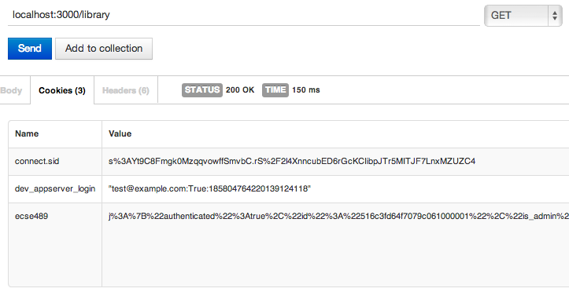

Figure Cookies

If a user is not admin, they get an error as shown in Figure 2

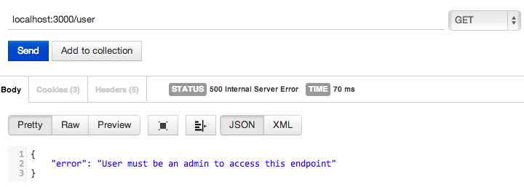

Figure Access Denied

##### Logout

Making a GET server/logout request clears the cookie and returns a response as shown in Figure 3

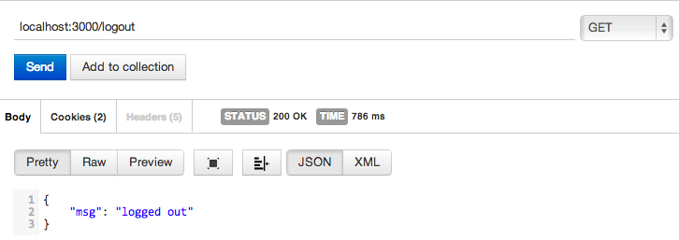

Figure User Logout

*User related functions*

##### Listing All Users

User must have admin privilege make this request.

GET server/user makes a query to the database that returns the collection of all users.

This request maps to the find({}) query sent to the database, which returns all of the contents of the User collection

##### Retrieving a Single User

Again, admin privilege is required. GET server/user/user001 queries the database with findOne() to return the document for the user ‘user001’ and the server returns its contents.

##### Creating a New User

No admin privilege is required to create a new user. To create a new user, a simple

POST server/user/user002 is required to create a non-admin user. The user details are specified in JSON format in the body of the request. The server then queries the database with the insert() command. This command also works for collections.

##### Updating a New User

Unlike creation, updating a user requires admin rights. A PUT server/user/user001 request updates a user profile, with the data in JSON format embedded in the body of the request. The server then queries the database with update(), which also creates the element if it doesn’t already exist.

##### Deleting a User

Deletion of a user works by updating the user profile to an empty one. Admin privilege is required and the request to perform it is DELETE server/user/user001, after which the server sends a remove() query to the database

*Data related functions*:

##### Retrieving data

There are two ways to get data, either an entire collection or a specific document. No admin privileges are required, however access to that collection or document is required. To retrieve an entire collection, GET server/collection/ will do the job.

GET server/collection/documentID will retrieve a specific document.

Filtering

GET server/collection?filter={“id”: “1234”}

Filter queries can be added as a HTTP query to the request. Sub attributes can also be specified such GET server/collection?filter={“book.author”: “obama”}

Ordering

Similar to filtering, ordering the data is also possible by adding an orderBy attribute to the HTTP request query such as

GET server/collection?orderBy={“id”: “asc”} for ascending order

Or GET server/collection?orderBy={“id”: “asc”} for descending order

Lastly, appending another query to the HTTP request as such can set a limit to the filtering/ordering:

GET server/collection?limit=12

##### Adding New Data

Adding a new document, given a user has the access to the collection, is simply accomplished by a POST server/collection/ or POST server/collection/documentID

with the data embedded in a JSON file in the body of the request.

##### Updating Data

Similar to adding data, PUT server/collection/documentID can be used to update a document, again with embedding the changes in JSON in a the request body

##### Deleting Data

Given that a user has access to a collection, deletion called by POST server/collection/ or POST server/collection/documentID request, with an empty JSON embedded in the request

### Response Codes

Every function returns a specific HTTP response code based on how the operation went. The implemented HTTP responses are outlined in Table 3.

|  |  |
| --- | --- |
| Code | Response |
| 200 | OK |
| 201 | CREATED |
| 202 | ACCEPTED |
| 400 | BAD REQUEST |
| 401 | UNAUTHORIZED |
| 402 | PAYMENT REQUIRED |
| 403 | FORBIDDEN |
| 404 | NOT FOUND |
| 405 | METHOD NOT ALLOWED |
| 500 | INTERAL SERVER ERROR |
| 501 | NOT IMPLEMENTED |

Table HTTP Response Codes

### Testing

The various functions that the server was designed to implement were tested using a test suite written in the Mocha framework. A total of 34 test were written (and passed!), the output of the test is shown in Figure 1

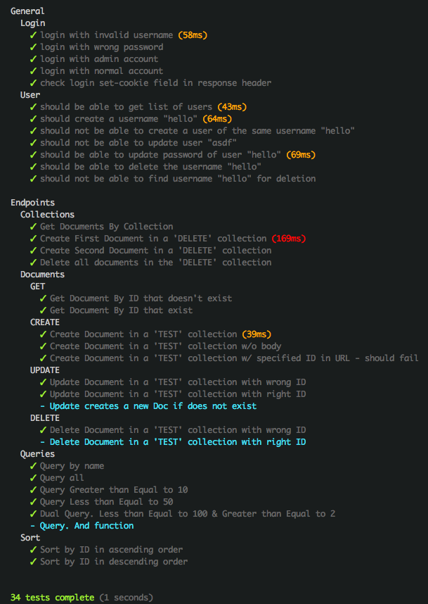

Figure Test Suite Output

### Conclusions and Further Work

The REST server was implemented successfully with the integration of a database as opposed to the XML data in the labs, which provides a much more robust and scalable data storage and manipulation. The technologies picked did indeed turn out to be ideal for a web-centric application like this, providing an excellent API for development, along with a very good performance. This project could be further improved by having adding an extra layer of security using HTTPS for the authentication. Furthermore, the server could be programmed to implement more query functions such as

AND, OR, NOR

>, <, >=, <=

≠, in, not-in

Lastly, the server could be updated to be able to manipulate multiple documents from one query, and simultaneously add to multiple collections.